ATTENTION L.A JEWISH COMMUNITY

DO YOU KNOW THIS MAN?

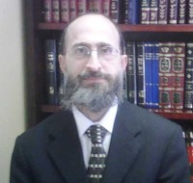
RABBI AVROHOM UNION
RCC RABBINIC ADMINISTRATOR
A CHRONIC VIOLATOR OF HALACHA

Rabbi Union has been accused of engaging in behavior that is not becoming of a Torah observing Rabbi. Such as:
עוות הדין, הוצאת שם רע, התרת אשת איש, הלבנת פני חבירו ברבים, הטמעת ממזרים בישראל, . פסול סירוב and for issuing a
These accusations arise from his involvement in matters of Hashgacha, financial disputes, and divorce. Rabbi Union has allowed greed to replace Halacha.If you see Rabbi Union, please encourage him to cease such behavior and do Teshuva.
. כא וְאַתָּה תֶחֱזֶה מִכָּל-הָעָם אַנְשֵׁי-חַיִל יִרְאֵי אֱלֹהִים, אַנְשֵׁי אֱמֶת--שֹׂנְאֵי בָצַע
ועשית הישר והטוב
COMMITTEE FOR SHOLOM AND EMES

