- Mark Sharf (SBN 140390) Merritt, Hagen & Sharf, LLP
- 5950 Canoga Ave, Suite 400
Woodland Hills, CA 91367
3 (818) 992-1940 Fax: (818) 992-3309
mark@sharflaw.com
4
Attorneys for Plaintiff
5
6
- UNITED STATES BANKRUPTCY COURT
- CENTRAL DISTRICT OF CALIFORNIA
- LOS ANGELES DIVISION

- In re: 11
Antony Gordon,
12
13
14
Brent J. Goldman,
15
16 v.
17
Antony Gordon,
18
19

Debtor.

Plaintiff,

Defendant.
) Chapter 7
) Bk No.: 2:13-bk-14465-DS
) Ap No.: 2:14-ap-01490-DS
)
)
) SETTLEMENT AGREEMENT
)
)
)
)
)
)
)
)
)
)
)

20 )

21
22
23
24
25
26
27
28

-1-

SETTLEMENT AGREEMENT

This agreement (the "Settlement Agreement") is entered into by and between Brent
- Goldman ("Plaintiff '), on the one hand, and Antony Gordon ("Defendant") on the other.

RECITALS

WHEREAS, on February 21, 2013 (the "Petition Date"), Antony Gordon filed a voluntary petition for relief under chapter 7 of title 11 of the United States Code (the "Bankruptcy Code") in the United States Bankruptcy Court for the Central District of California;
WHEREAS, on or about July 19, 2014, Plaintiff filed the Complaint To Determine Debt

To Be Non-Dischargeable (the "Complaint"), commencing Adversary Proceeding Number 2: 14- ap-01490 (the "Adversary Proceeding");
WHEREAS, Plaintiff has alleged in the Complaint that an obligation owed to Plaintiff m an amount of not less than $844,000 is non-dischargeable under 11 U.S.C. §523.
WHEREAS, considering the risks and costs involved in the litigation, the Plaintiff and Defendant have agreed to resolve their dispute on terms mutually acceptable to each party, subject to approval by the United States Bankruptcy Court.
NOW, THEREFORE, IT IS HEREBY STIPULATED AND AGREED, by

and between the parties as follows:

  - The attached Stipulated Judgment in the amount of $225,000 (the "Stipulated Judgment") shall be entered immediately and shall bear simple interest at the rate of ten percent per annum. Defendant consents to the entry of said Stipulated Judgment and agrees that the full amount of the obligation represented by said Stipulated Judgment is

non-dischargeable in this and any future bankruptcy proceeding.

1
Plaintiff agrees not to

record nor enforce said Stipulated Judgment for a period of eight (8) months from the date it is entered provided that Anthony Gordon executes the declaration attached hereto concurrently herewith.
- Both Antony Gordon and his spouse, Elizabeth Joy Gordon, shall promptly provide Brent Goldman with complete access to the current and future tax returns and bank account statements of a) Antony Gordon, b) Elizabeth Joy Gordon, and c) any company which Antony Gordon and/or Elizabeth Joy Gordon directly or indirectly own any portion of and/or controls. Antony Gordon and Elizabeth Joy Gordon shall promptly provide any such documents when they are requested by Brent Goldman via email to the following email address: Gordon@brentgoldman.com. "Promptly" shall be defined as within five (5) business days of when said email is sent.
- Each side shall bear his own fees and expenses incurred in connection with

the within adversary proceeding, except to the extent said amounts are already included in the Stipulated Judgment amount.
- In consideration of the agreement set forth herein, except as to the obligations arising hereunder and t h e o b 1i g at i o n set fo r t h i n t h e Stipulated Judgment, and conditioned upon the approval of this Settlement Agreement by the Bankruptcy Court in the Antony Gordon bankruptcy case (without the filing of an appeal thereafter), Plaintiff shall forever withdraw, release, discharge, waive and forgive Defendant and his assigns, administrators and successors in interest, for and from any and all claims, actions, causes
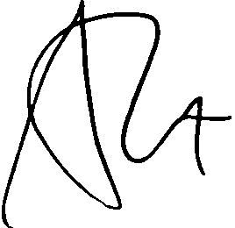of action, counterclaims and any other obligation of any kind or nature; provided, however, that the foregoing shall not constitute a release of any rights to enforce the Stipulated Judgment, the terms of this Settlement Agreement, nor shall it constitute a release of any right to assert a claim against the Defendant's bankruptcy estate.

2

- Conditioned upon and subject to approval of this Settlement Agreement by the Bankruptcy Court in the Antony Gordon bankruptcy case (without the filing of an appeal thereafter), Defendant shall forever withdraw, release, discharge, waive and forgive the Plaintiff, and each of his respective assigns, administrators and both predecessors and successors in interest, for and from any and all claims, actions, causes of action, counterclaims, and any other obligation of any kind or nature; provided, however, that the foregoing shall not constitute a release of any rights to enforce the terms of this Settlement Agreement.
- THE PARTIES HEREBY EXPRESSLY WAIVE THE PROVISIONS OF CALIFORNIA CIVIL CODE SECTION 1542 WHICH PROVIDES THAT "A GENERAL RELEASE DOES NOT EXTEND TO CLAIMS WHICH THE CREDITOR DOES NOT KNOW OR SUSPECT TO EXIST IN HIS OR HER FAVOR AT THE TIME OF EXECUTING THE RELEASE, WHICH IF KNOWN BY HIM OR HER MUST HAVE MATERIALLY AFFECTED HIS OR HER SETTLEMENT WITH THE DEBTOR."

- This Settlement Agreement may be executed by the parties on separate counterparts, each of which, when so executed, shall be deemed an original, but all such counterparts shall constitute one and the same instrument. Any executed copy of this Agreement delivered by confirmed facsimile or electronic mail shall be deemed to be binding to the same extent as an original executed copy of this Settlement Agreement.
- This Settlement Agreement shall be binding upon and shall inure to the benefit of the Parties hereto and their legal representatives, predecessors, successors and assigns. This Settlement Agreement is subject to approval by the Bankruptcy Court.
- The Parties to this Settlement Agreement acknowledge that they have read all of the terms of this Settlement Agreement and have entered into those terms voluntarily after obtaining the advice of independent legal counsel. This Settlement Agreement shall be

deemed to have been jointly drafted by the

3

Parties hereto and shall be

accordingly. No provision ·shall be construed or interpreted for or against either of the Parties to this Settlement Agreement. The ind ividuals signing this Settlement Agreement on behalf of the Parties to the Agreement represent and warrant that they are duly authorized and fully competent to do so.
I 0. It is expressly understood and agreed that the tenns hereof: including the recital paragraphs and headings, are contractual and that the agreement herein contained and the consideration transferred is to compromise disputed claims. This Settlement Agreement contains the entire agreement and understanding between the Parties pertaining to the subject matter of this Settlement Agreement and supersedes and replaces all prior and contemporaneous negotiations, agreements and proposed agreements, written or oral. This Selllement Agreement may be modified only be a writing signed by each of the parties hereto or their duly appointed agents.
  - 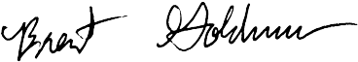The United States Bankruptcy Court for the Central District of California shall retain exclusive Jurisdiction to interpret and enforce the terms of this Settlement Agreement and to resolve any disputes in connection herewith. This Settlement Agreement shall be interpreted and enforced pursuant to the laws of the State of California.

Dated: November , 2014

Dated: Novembef 22014

Brent J. Goldman

Anro

4

----· --

DECLARATION OF ANTONY GORDON

I, Anthony Gordon, do hereby declare:

    - I am over the age of eighteen years and am competent to give this declaration. The facts stated herein are known by me to be true and correct from my own personal knowledge. If called upon as a witness I could and would competently testify to the facts stated herein.
    - During 2012 and 2013 I paid a combined total of $75,000 to various people with the explicit comm itment from Mr. Don Watson that said funds would be replaced almost immediately. The funds paid to them were the property of Brent J. Goldman. Brent J. Goldman had merely entrusted his funds to me, and was unaware of the disposition of said funds until after they were expended.
I declare under penalty of perjury under the laws of the State of California and under the laws of the United States of America that the foregoing is true and correct, and that this declaration was executed this Q_day of Novem ber, 2014 at Los Angeles, California.

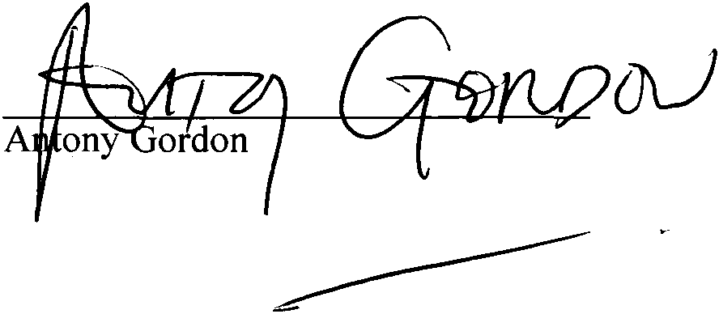

5

- Mark Sharf (SBN 140390) Merritt, Hagen & Sharf, LLP
- 5950 Canoga Ave, Suite 400
Woodland Hills, CA 91367
3 (818) 992-1940 Fax: (818) 992-3309
- mark@sharflaw.com
- Attorneys for Brent J. Goldman
- UNITED STATES BANKRUPTCY COURT
7 CENTRAL DISTRICT OF CALIFORNIA
8 LOS ANGELES DIVISION
9
10 In re: Chapter 7
Bk No.: 2:13-bk-14465-DS

11 ANTONY GORDON,
12 Debtor.
Ap No.: 2:14-ap-01490-DS

13

JUDGMENT

14 BRENT J. GOLDMAN 15
- v.

Plaintiff,

- ANTONY GORDON

- Defendant.
19
- After consideration of the Complaint, the Answer, and the
- Settlement Agreement submitted in this matter, the Court being
- fully advised and good cause appearing therefore, judgment is
22 hereby rendered as follows:

23
- Brent J. Goldman shall have and recover judgment
24
against Antony Gordon in the amount of $225,000 plus interest
25
thereon at 10% per annum simple interest, commencing from the
26
date of the entry of this Judgment. This obligation is hereby
27
determined to be non-dischargeable pursuant to Section 523(a) (2)
28

1
of the United States Bankruptcy Code.
2
3 ###
4

5
6

7

8

9

10
11

12

13
14

15
16

17
18
19
20

21

22

23

24
25
26
2 7

28

PROOF OF SERVICE OF DOCUMENT
2 I am over the age of 18 and not a party to this bankruptcy case or adversary proceeding. My business address is:
3 5950 Canoga Avenue, #400 Woodland Hills, CA 91367
4
A true and correct copy of the foregoing document described SETILEMENT AGREEMENT will be served or
5 was served (a) on the judge in chambers in the form and manner required by LBR 5005-2(d); and (b) in the
manner indicated below:
6
- TO BE SERVED BY THE COURT VIA NOTICE OF ELECTRONIC FILING ("NEF"l - Pursuant to controlling
7 General Order(s) and Local Bankruptcy Rule(s) ("LBR"), the foregoing document will be served by the court vi NEF and hyperlink to the document. On November 18, 2014, I checked the CM/ECF docket for this bankruptc
8 case or adversary proceeding and determined that the following person(s) are on the Electronic Mail Notice List t receive NEF transmission at the email address(es) indicated below:
9
- Mark M Sharf mark@forbankruptcy.com, msharfOO@gmail.com

1o • Andrew Edward Smyth office@smythlo.com
- United States Trustee (LA) ustpregion16.la.ecf@usdoj.gov
11

D Service information continued on

12 attached page
II. SERVED BY U.S. MAIL OR OVERNIGHT MAIL(indicate method for each person or entity served):
13
On November 18, 2014, I served the following person(s) and/or entity(ies) at the last known address(es) in thi bankruptcy case or adversary proceeding by placing a true and correct copy thereof in a sealed envelope in th
- United States Mail, first class, postage prepaid, and/or with an overnight mail service addressed as follows .
Listing the judge here constitutes a declaration that mailing to the judge will be completed no later than 24 hour
- after the document is filed.
- Hon. Deborah J Saltzman United States Bankruptcy Court
- 255 E. Temple Street, Suite 1334 Los Angeles, CA 90012
18
Andrew Edward Smyth

- Smyth Law Office
4929 Wilshire Blvd Ste 690
- Los Angeles, CA 90010

21 attached page

D Service information continued on

22 111. SERVED BY PERSONAL DELIVERY FACSIMILE TRANSMISSION OR EMAIL indicate method for eac person or entity served): Pursuant to F.R.Civ.P. 5 and/or controlling LBR, on March 21, 2014 , I served th
- following person(s) and/or entity(ies) by personal delivery, or (for those who consented in writing to such servic method), by facsimile transmission and/or email as follows. Listing the judge here constitutes a declaration tha
personal delivery on the judge will be completed no later than 24 hours after the document is filed.
- D Service information continued on
- attached page
I declare under penalty of perjury under the laws of the United States of America that the foregoing is true and
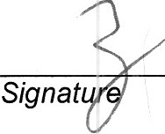26 correct.
- November 18, 2014 Kahra Stiver

- Date Type Name

-1-

