Case 2:13-ap-01536-DS Doc 77 Filed 11/04/14 Entered 11/04/14 12:46:26 Desc Main Document Page 1 of 3

- JEREMY W. FAITH (State Bar No. 190647) MEGHANN TRIPLETT (State Bar No. 268005)

MARGULIES FAITH LLP
FILED & ENTERED

CLERK U.S. BANKRUPTCY COURT
Central District of California BY egarcia DEPUTY CLERK
- 16030 Ventura Blvd., Suite 470 Encino California 91436

NOV 04 2014
4 Telephone: (818) 705-2777
Facsimile: (818) 705-3777
5 Email: Jeremy@MarguliesFaithLaw.com Email: Meghann@MarguliesFaithlaw.com
6
Attorneys for Plaintiffs Howard Fialkov,
- HJG Partnership and 1568931 Ontario LTD

UNITED STATES BANKRUPTCY COURT CENTRAL DISTRICT OF CALIFORNIA
- LOS ANGELES DIVISION
10

- In re
- ANTONY GORDON, 13

Debtor.
Case No.: 2:13-bk-14465-DS
Chapter: 7
Adv. No.: 2:13-ap-01536-DS

1568931 ONTARIO LTD., an Ontario
- (Canada) Corporation; HJG PARTNERSHIP, an Ontario (Canada)
- Partnership, and HOWARD FIALKOV,
- an individual,

SUMMARY JUDGMENT AGAINST DEFENDANT ANTONY GORDON FOR DENIAL OF DISCHARGE OF DEBT PURSUANT TO 11 U.S.C. § 523(a)(2)(A) AND 523(a)(6)

- vs. 18
Plaintiff,

Hearings:
Date: September 30, 2014

ANTONY GORDON, an individual,
- Defendant.
- ANTONY GORDON,
- Cross-Complainant,
- v.
- HOWARD FIALKOV,
- Cross-Respondent.
25
26
27
28
Time: 1:30 p.m.
Date: October 8, 2014
Time: 11:00 a.m.
Place: Courtroom 1339
United States Bankruptcy Court 255 E. Temple Street
Los Angeles, CA 90012

Case 2:13-ap-01536-DS Doc 77 Filed 11/04/14 Entered 11/04/14 12:46:26 Desc Main Document Page 2 of 3

  - The motion of Plaintiffs Howard Fialkov, HJG Partnership and 1568931 Ontario
  - LTD (collectively “Plaintiffs”) for summary judgment, or in the alternative, summary
  - adjudication of the issues, as to Plaintiffs’ claims for non-dischargeability of certain debts
  - asserted against Defendant (the “Motion”) in the above-captioned adversary proceeding
  - came on regularly for hearing on September 30, 2014 at 1:30 p.m. in the United States
  - Bankruptcy Court for the Central District of California, the Honorable Deborah J.
  - Saltzman, United States Bankruptcy Court Judge presiding. Appearances were as
  - stated on the record.
  - The Court, held a continued hearing on October 8, 2014 at 11:00 a.m. at which
  - time, having determined that the Motion was duly noticed to all interested parties; having
  - considered the parties’ pleadings and evidence therein; and having entertained oral
  - argument, and based on the accompanying Statement of Uncontroverted Facts and
  - Conclusions of Law, for the reasons stated on the record at the continued hearing on
  - October 8, 2014, and for good cause appearing,

IT IS HEREBY ORDERED that:
  - 1. Plaintiffs’ Motion is GRANTED;
  - 2. Summary Judgment is granted in favor of Plaintiffs and against Defendant
  - Antony Gordon with respect to Plaintiffs’ First Claim for Relief for the nondischargeability
  - of debt in the amount of $7,600,000.00 pursuant to 11 U.S.C. § 523(a)(2)(A), as all
  - elements of said claim were satisfied;
  - 3. Summary Judgment is granted in favor of Plaintiffs and against Defendant
  - Antony Gordon with respect to Plaintiffs’ Second Claim for Relief for the
  - nondischargeability of debt in the amount of $1,600,000.00 pursuant to 11 U.S.C. §
  - 523(a)(6), as all elements of said claim were satisfied; and 25 ///
26 ///
27 ///
28 ///

Case 2:13-ap-01536-DS Doc 77 Filed 11/04/14 Entered 11/04/14 12:46:26 Desc Main Document Page 3 of 3

    - 4. This Judgment is without prejudice to the rights of Plaintiffs to seek
    - attorneys’ fees and costs from Defendant as provided for under applicable law.
    - IT IS SO ORDERED.
4 ###
5
6
7
8
9
10
11
12
13
14
15
16
17
18
19
20
21
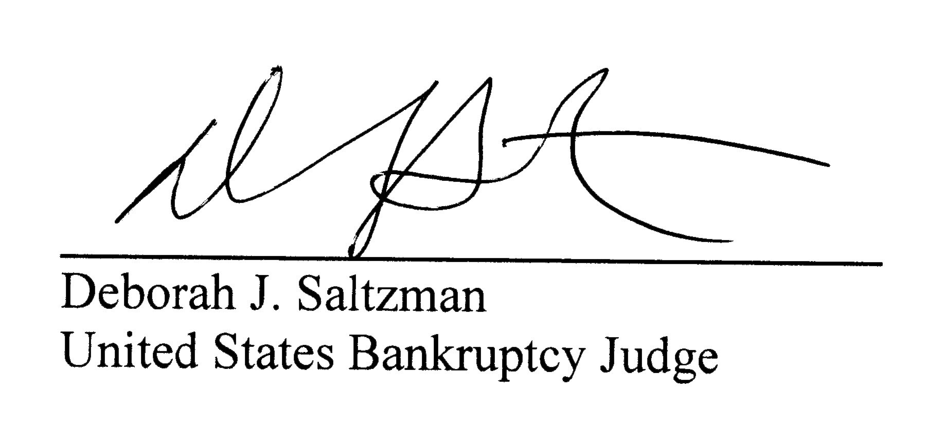22
23
24 Date: November 4, 2014
25
26
27
28

